Computer Networks Sample Questions

____ 1. The time that a router spends in routing table lookup, is part of which type of delay?

- Propagation delay
- Queueing delay
- Transmission delay
- Processing delay

_____ 2. Which protocol has both an infrastructure mode and an ad hoc mode?

- SMTP
- BGP
- WiFi
- DNS

_____ 3. Which protocol helps disseminate AS-level reachability information within an AS?

- RIP
- OSPF
- i-BGP
- e-BGP

_____ 4. Which of the following does NOT happen within a router?

- Fast retransmit
- Output port queueing
- Head-of-line blocking
- Longest prefix matching

_____ 5. The exchange of RTS and CTS messages in WiFi is introduced to address which problem?

- Head-of-line blocking
- Hidden terminal problem
- Exposed terminal problem
- Count-to-infinity problem

_____ 6. A NAT gateway changes the following fields of a packet going from the internal (local area) network to the external (wide area) network:

- Source IP address
- Source IP address and source port number
- Destination IP address
- Destination IP address and destination port number

_____ 7. Which pair of protocols adopt Internet Checksum for error detection?

- Pop3 and SMTP
- TCP and UDP
- IPv4 and IPv6
- Ethernet and WiFi

_____ 8. Who invented the Ethernet and won the 2022 Turing Award?

- Zongpeng Li
- Vint Cerf
- Jim Kurose
- Bob Metcalfe

_____ 9. In slotted Aloha, each type of slot (Success, Empty, Collision) has length 1. We now introduce collision detection, such that a Collision slot has length 0.2 instead of 1. What is the efficiency of this “slotted Aloha with CD” protocol?

- Below 40%
- Between 40% and 50%
- Between 50% and 60%
- Above 60%

_____ 10. Which of the following is NOT directly related to SDN?

- Openflow
- OpenDaylight
- ONOS
- CDMA

11. The multimedia streaming protocol DASH is based on UDP.

Pick one by circling: TRUE FALSE

12. Selective-repeat ARQ is always more efficient than Go-back-N ARQ.

Pick one by circling: TRUE FALSE

13. Openflow adopts an “match + action” approach, for performing generalized forwarding.

Pick one by circling: TRUE FALSE

14. Ethernet’s MAC protocol is unslotted CSMA/CA with binary backoff.

Pick one by circling: TRUE FALSE

15. Wireless signal attenuates as it propagates in the air, and signal strength is inversely proportional to distance of travel.

Pick one by circling: TRUE FALSE

16. Link-layer switches decrement the TTL field in the IP header.

Pick one by circling: TRUE FALSE

17. TCP implements flow control, while UDP does not.

Pick one by circling: TRUE FALSE

18. Token Ring is an example of the “taking-turns” MAC protocol.

Pick one by circling: TRUE FALSE

19. A shortest path tree computed by link-state routing is a minimum spanning tree.

Pick one by circling: TRUE FALSE

20. During the slow start phase of TCP congestion control, cwd increases exponentially as a function of RTT.

Pick one by circling: TRUE FALSE

21. Draw a line to connect each protocol with the layer that it belongs to.

Openflow
Application layer

Transport layer

Network layer

Data link layer

ICMPv6

BitTorrent

TCP

Pop3

ARP

ISIS

Bluetooth

22. Name three differences between traditional Internet routing and the SDN approach to routing.

(1)

(2)

(3)

23. Reliable data transfer: forward error correction (FEC) and ARQ

FEC: For each group of p data packets (of equal size), the source generates q parity packets, such that any p out of these (p+q) packets can be used to recover the original p packets. The source then transmits original data packets and parity packets to the receiver across the network.

- Name an advantage of FEC over ARQ.

- Name an advantage of ARQ over FEC.

- Assume that someone attempts to combine FEC with Go-back-N ARQ, so that the input to the ARQ sender includes both original data packets and parity packets. What changes to the ARQ mechanism would you suggest him/her to consider?

24. Assume that in CRC checksum computation, the data packet is 110010, the 4-bit generator is 1101. (i) What is the 3-bit CRC checksum? (ii) Construct a different 6-bit binary sequence, with the same 3-bit CRC checksum.

25. The following diagram illustrates AIMD congestion control between two network connections who share a bottleneck link. These two connections have the same RTT. Now, assume that the RTT of connection 1 equals 50% of the RTT of connection 2, draw a new AIMD diagram starting from the same initial point A.

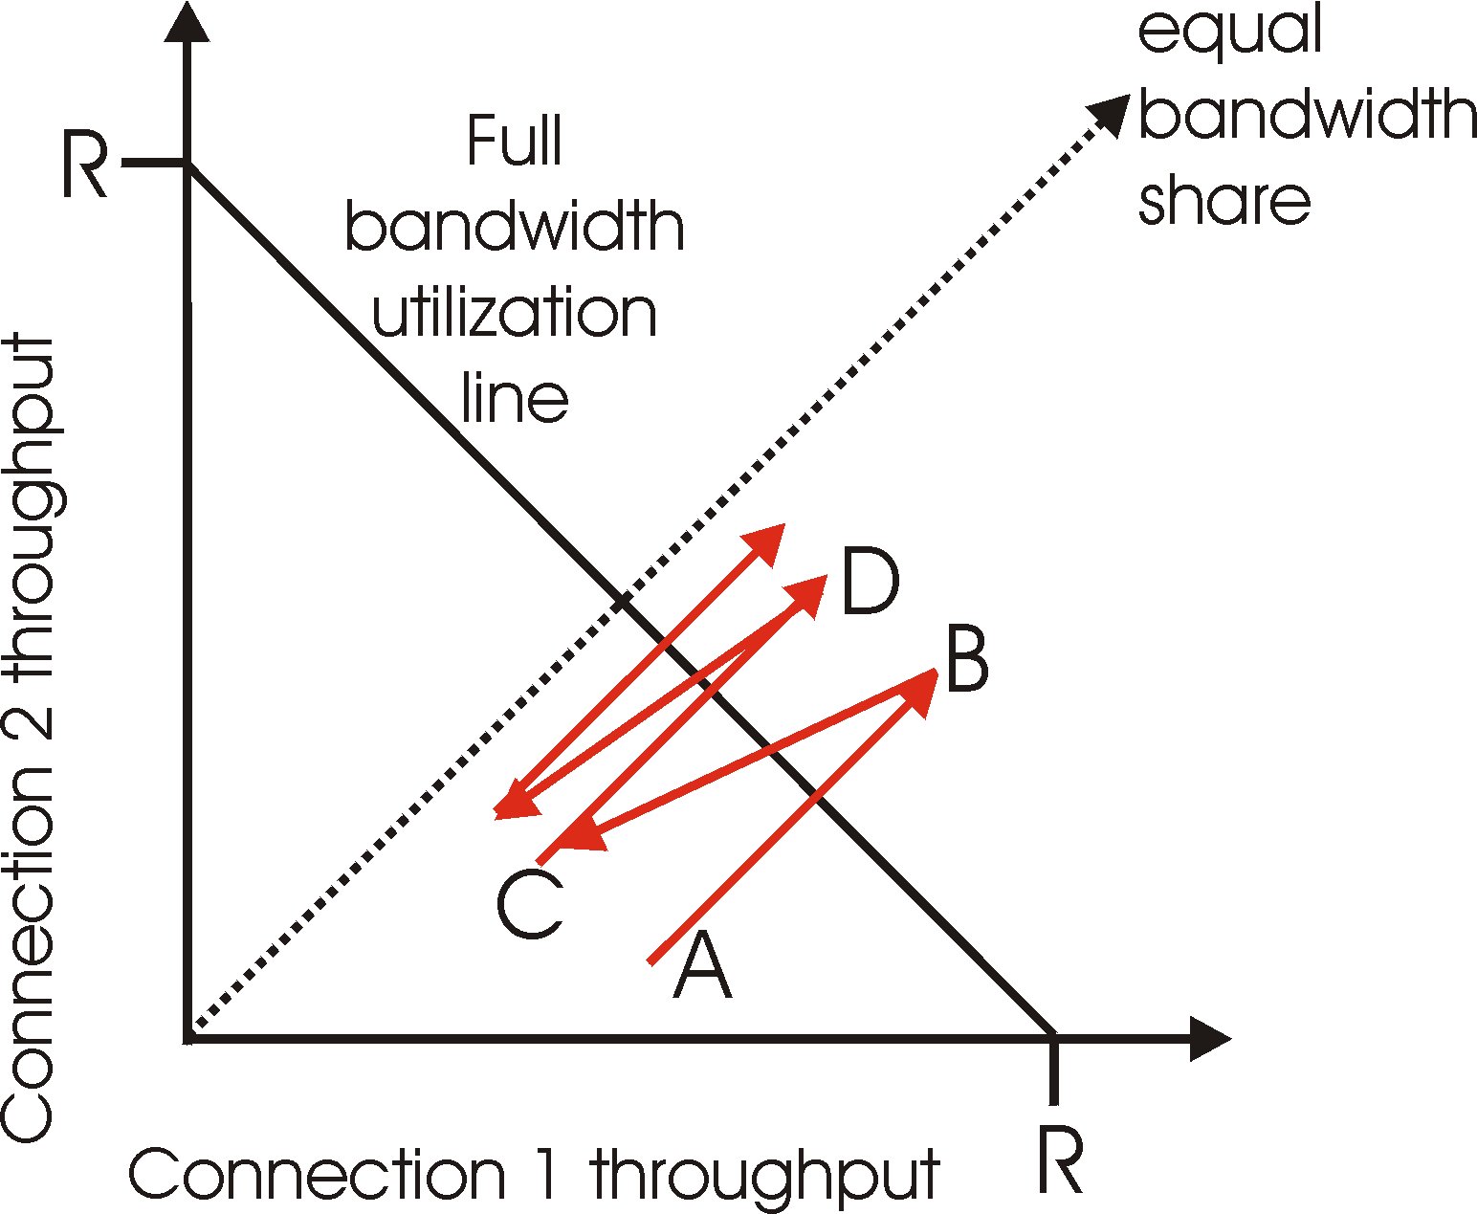

26. Answer the following questions about MPLS.
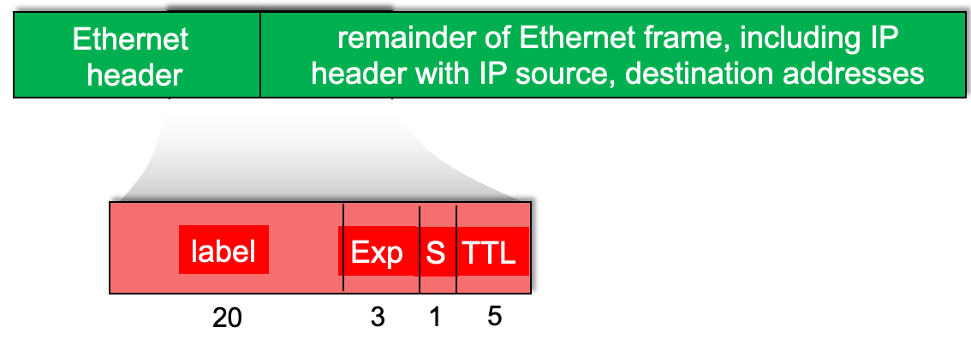

(0) (bonus, 2 points) The figure above has an error. What is the error?

(1) Which of the four fields (label, Exp, S, TTL) is used to indicate priority of a data packet?

(2) In the figure below, when an MPLS packet with destination A arrives at router R4, will it be forwarded to R2 or R3?
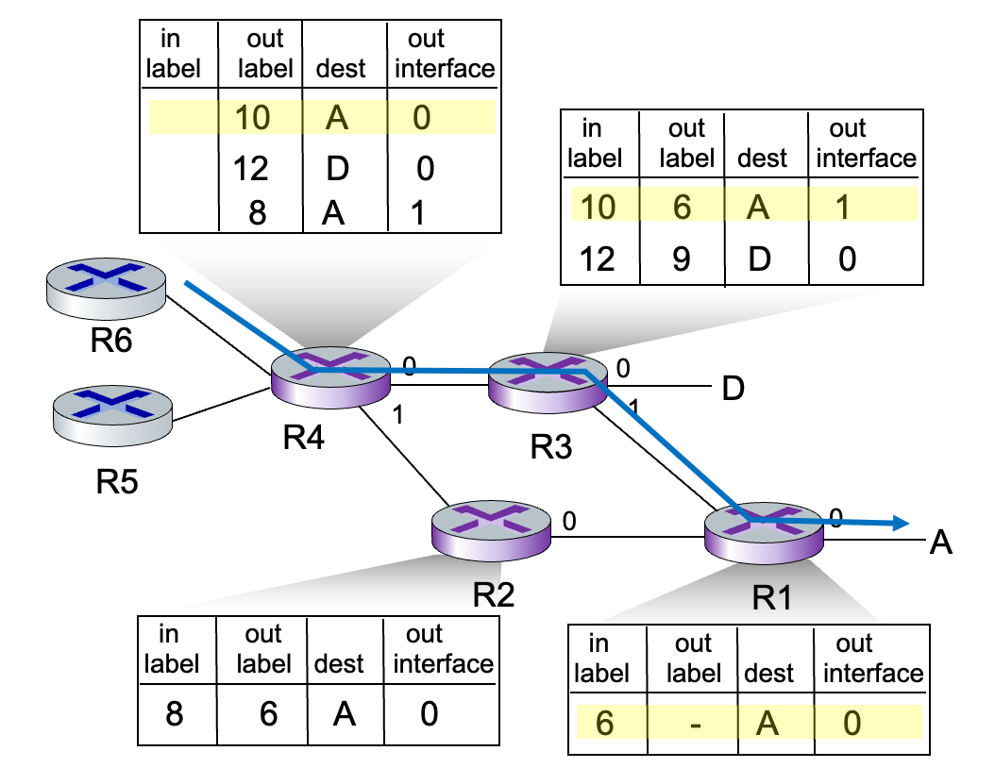

(3) Name a potential benefit of fixed-length label switching, as compared with longest-prefix matching in destination-IP-based forwarding.

Fill in Blank

27. The four types of delay that make up end-to-end data transmission delay on the Internet include processing delay, _________________, propagation delay and queueing delay.

28. The four components within a router include router processor, input ports, __________________, and output ports.

29. In TCP flow control, a TCP receiver advertises __________________________ in the rwnd field in TCP header.

30. The mechanism for alleviating IPv4 address shortage, which uses a single public IP address and port numbers to address different processes within a LAN, is known as _____________________________.

31. The _________________ protocol is also known as a path vector protocol.

32. SDN implements separation between ____________ plane and _____________ plane.

